Sorting

Bubble sort

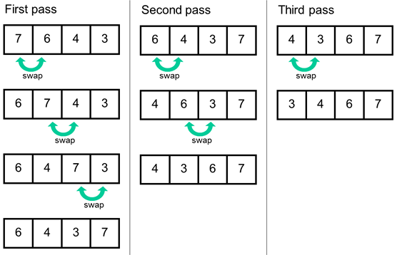

Time complexity => O(n\*n)

Insertion sort

Time complexity => O(n\*n)

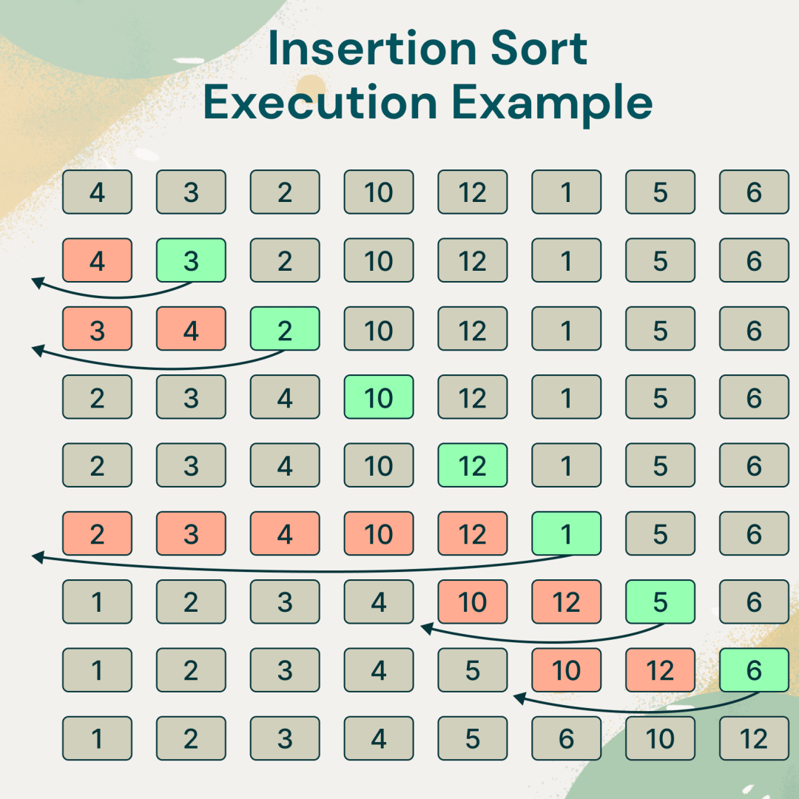

Selection sort

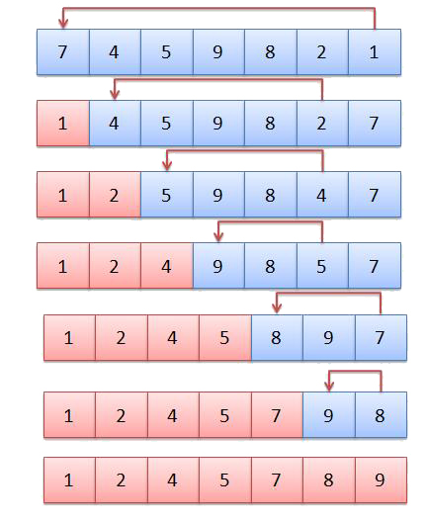

time complexity => O(n\*n)

Merge sort

Time complexity => O(n\*log(n))

Shell sort

Variation of insertion sort

Uses gap concept

Time complexity depends on gap value

Worst case at optimal gap value =>  O(n\*(log n)\*(log(n))

Quick sort => O(N log(N))

Uses pivot value and partitioning